**FETAL-HEALTH**

**Industry Review:**

A diagnostic tool used to monitor movement and heart rate of the fetus and maternal contractions is known as fetal monitoring system. It is a fundamental device used for monitoring uterine contractions during labor. It mainly monitors well-being of fetus and progress of labors. In medical terms, it is referred as medical method to check health of an unborn baby to ensure a safe birth. So it is very important for fetal health.

**Context:**

Reduction of child mortality is reflected in several of the United Nations' Sustainable Development Goals and is a key indicator of human progress.  
The UN expects that by 2030, countries end preventable deaths of new born and children under 5 years of age, with all countries aiming to reduce under‑5 mortality to at least as low as 25 per 1,000 live births.

Parallel to notion of child mortality is of course maternal mortality, which accounts for **295 000 deaths** during and following pregnancy and childbirth (as of 2017).

The vast majority of these deaths **(94%)** occurred in low-resource settings, and most **could have been prevented**.

**Objective**:

Main Objective is Classify fetal health in order to prevent child and maternal mortality.

**Dataset Features and Description:**

This dataset contains 2126 records and 22 columns of features extracted from Cardiogram exams, which were then classified by three into 3 classes:

* Normal
* Suspect
* Pathological

Then the target variable split in to normal and abnormal.

**Technology Used:**

Python-ML Algorithms (supervised classification), Numpy, Pandas.

Multivariate Analysis

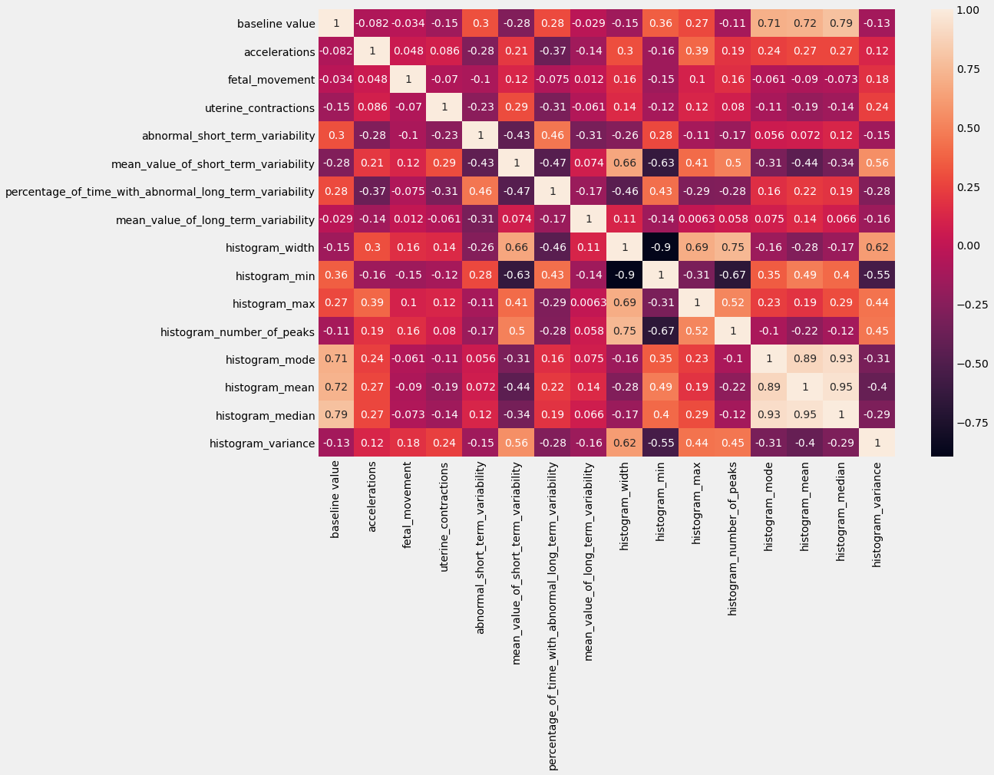

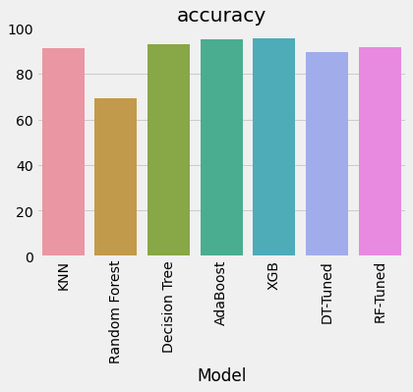

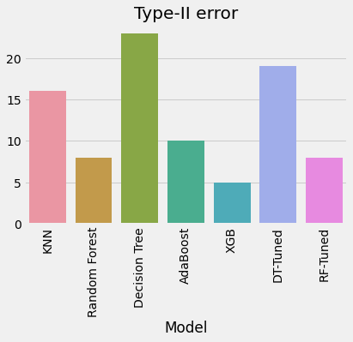

**Final Report**:

XGB Classifier has the highest accuracy and Type 2 error also very less. So the best model is XGB Classifier.

**Confusion Matrix-XGB Classifier**

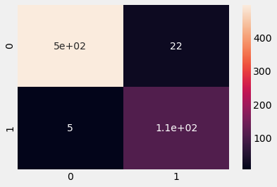

**Correct and Miss classification:**

**[[497 22]**

**[ 5 110]]**

* In this chart we can see XGB Classifier hast the highest accuracy and less error.
* XGB model predicts correctly 92.8% of the fetal has classified normal and 20.7% of the fetal classified has abnormal.
* 0.9% of the fetal actually normal but misclassified has abnormal and 20.7% are actually abnormal but classified has normal.